## Square Foot Gardening

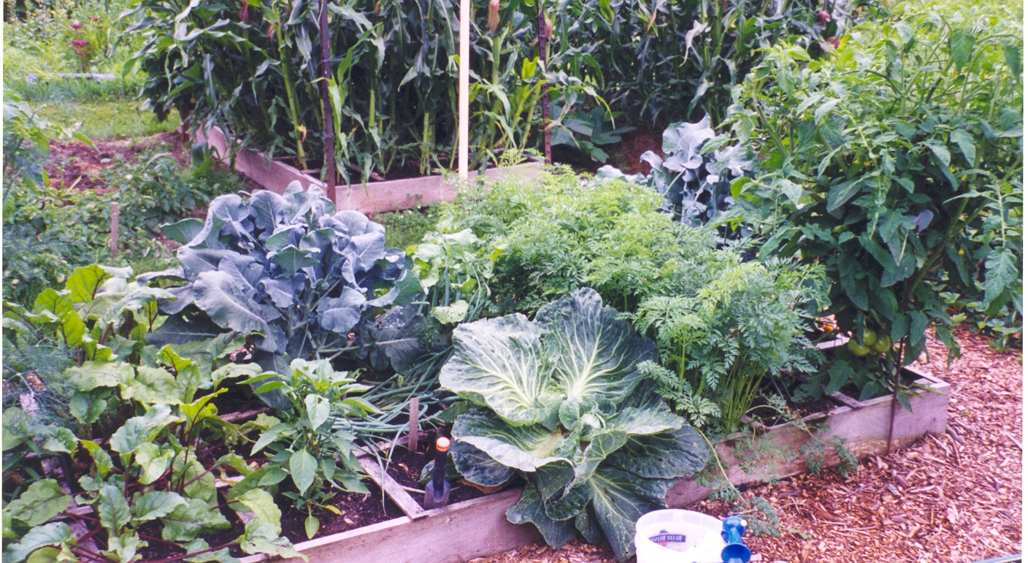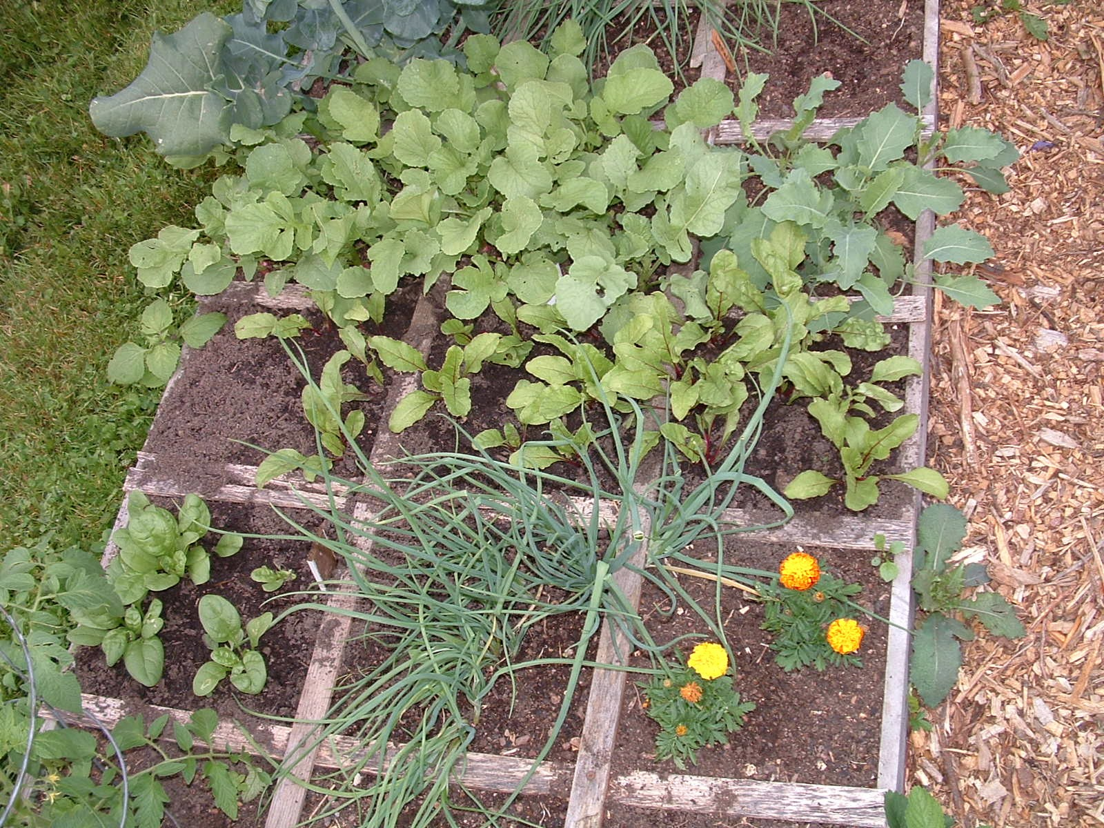

**A simplified method of gardening,**

**practiced around the world.**

Needs no special or expensive equipment,

investment, fertilizer, or experience.

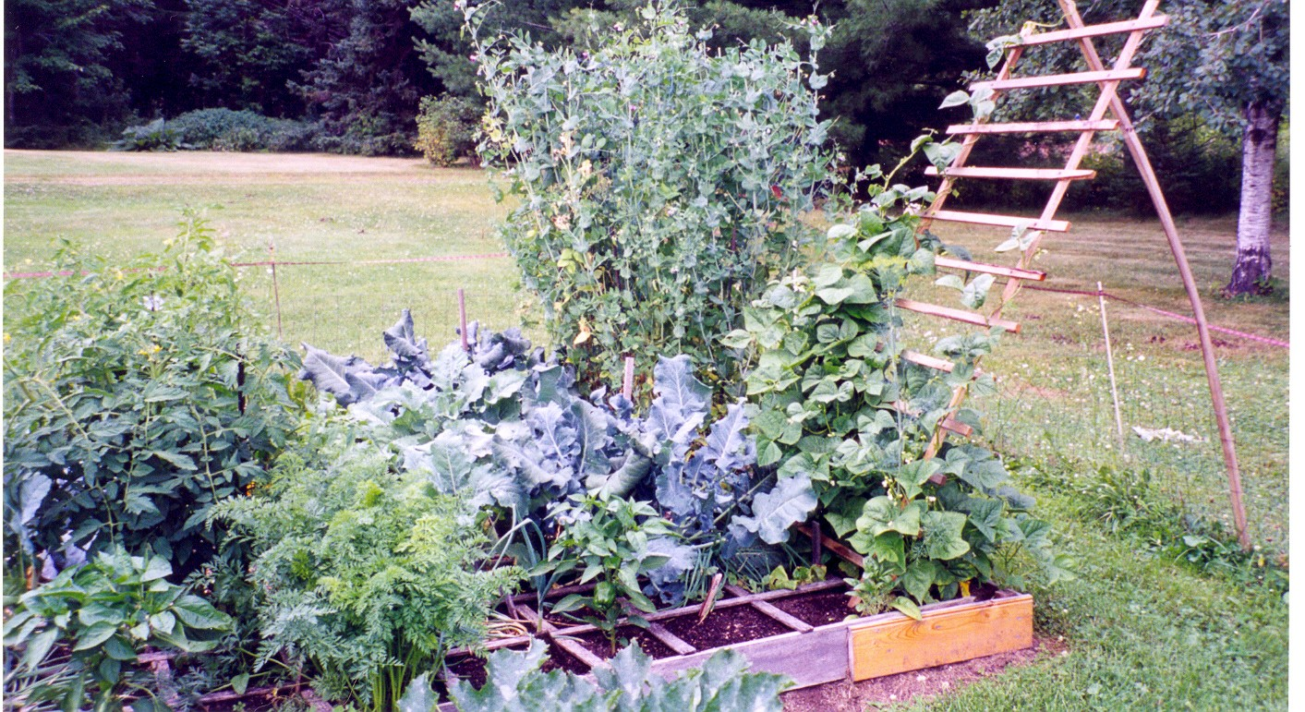

Notes distributed by

Arlen Albrecht, CRD Agent

UW-Extension

925 Donald Street, Room 103

Medford, WI 54451-2095

from a class taught by

Mel Bartholomew and Suzy Valentine

Copyright © 1999

### WHY YOU WILL ABSOLUTELY LOVE SQUARE FOOT GARDENING

#### LESS WEEDING – NO TILLING – NO HEAVY DIGGING – LESS WORK

### What is the Square Foot Method of Gardening?

**Square foot gardening (SFG)** is more than just another new method of planning and planting a garden; it is a whole different psychological approach to gardening. The square foot garden is divided into a size and shape that gardeners of all ages, sizes and levels of experience can understand and cope with easily. The system is simple, but versatile. It can be adapted to fit all kinds of gardening situations. Whether you want to grow all your own food or just enough for a few salads a week, whether you live alone or have a large family, whether you live in the city or in the country, with a lot of land or a little, you will be able to adapt the principles of square foot gardening to meet your needs. The garden will be well organized, easy to maintain, attractive and productive all season long.

### Limiting the Size of the Garden

The square foot garden really is easy to maintain, basically because it sets limits for us ahead of time. In developing this method, considerable time was spent looking for ways to make gardening less work. The entire concept of square foot gardening is the result of that search for an easier, more foolproof way to garden. The basic concept of growing more food in less space has been tried by many. SFG establishes definite limits, or boundaries, within which you will garden. It limits the amount of space, and thereby time, you will devote to each vegetable, chore and step in the garden. Beginners and experts alike will enjoy this easy to learn – easy to do method. Requires very little space**; 80% less space than** conventional gardening. It can be done in as little as 4 feet by 4 feet or 2 feet by 2 feet, but it can also be done as large as you want and get five times more production than a conventional garden in comparable space.

**Advantages of Square Foot Gardening**

* **Your existing soil doesn’t matter** because it will be replaced with a perfect growing medium that is weed-free and requires no tilling.
* **Use much less water**; only about 10% of the water that is required for conventional gardening.
* No fertilizers or pesticides to handle – **it is all organic.**
* The planting method results in **very little thinning** and many fewer seeds are used.
* **Can be done by those with physical limitations.** All that is needed are two fingers. If stooping or bending is a problem, raise the boxes to a comfortable level. Can be done from a wheelchair.
* Makes **a great family project** because all ages can participate; even kids like doing it. No longer do kids get stuck doing nothing but weeding – because there are none! Kids can do SFG almost by themselves.

##### SQUARE FOOT GARDENING BASICS

###### Create a Beautiful *(Little Work)* Garden

Here’s a quick overview. Build a square frame that is no wider than 4 feet and is 6 to 8 inches deep. The length is not as important, but a recommended size for your first time is one frame 4 feet by 4 feet. You can, of course, go smaller. 1” by 6” lumber is ideal, and comes in 8-foot lengths. Most lumber yards will cut it for you at little or no cost. Exact dimensions are not important. Two inch long deck screws work best to fasten the boards together at the corner.

Since you will NEVER walk on or depress the growing soil, do not make the frames any wider than 4 feet (2 feet if only one side is accessible). Any wider makes it too difficult to reach in to tend the plants. If you plan to have more than one growing bed, separate them by 2 or 3 feet to form walkways.

Fill the frame with a mixture of 1/2 compost and 1/2 peat moss, or 100% compost (no soil needed). Compost provides all the nutrients the plants require (no chemical fertilizers needed). Peat moss helps hold moisture and keep the soil loose. When buying compost, make sure it is truly compost. Some stores sell mulch and other ground covers but call it compost. It is best to make your own compost; then you know what goes in it.

If placing frames over grass or weeds, first lay down several layers of newspaper or cardboard to discourage grass and weeds from coming up through, because they will, especially dandelions.

On top of each frame, place a grid that divides the box into one foot squares. The grid is the unique feature that makes the whole system work so well. To show you why the grid is so important, do this little demonstration: Look at your 4 ft by 4 ft box with the grid on and imagine up to 16 different crops. What you see before you is a neat and attractive, well organized garden that will be easy to manage. Now remove the grid. Could you still organize and manage this space without dividing it up into squares? Besides, without the grid you will be tempted to plant in rows, which is a poor use of space.

Grids can be made from nearly any material; wood, plastic strips, old venetian blinds, etc. Use screws to attach them where they cross. On a 4 foot by 4 foot frame, the grid divides the frame into 16 easy-to-manage spaces, for up to 16 different crops. **Leave the grid in place all season.**

Depending on the mature size of the plant, grow 1, 4, 9, or 16 equally spaced plants per square foot. If the seed packet recommends plant spacing be 12 inches apart, plant one plant per square foot; if 6 inch spacing, plant 4 per square foot; if 4 inch spacing, plant 9 per square foot; if 2 inch spacing, plant 16 per square foot.

Plant one seed in each spot by making a shallow hole with your finger. Cover, but do not pack the soil. Thinning is all but eliminated. Seeds are not wasted. Extra seeds can be stored for two or more years. Don’t overplant. Plant only as much of any one crop as you will use. A 4 foot by 4 foot box will grow more than a conventional garden that is 10 feet by 10 feet.

Water only as much as each plant needs. Water often, especially at first, and on very hot dry days. But be careful not to overwater – this special soil holds water like a sponge. Water by hand from a sun-warmed bucket of water. Warm water helps the soil stay warm. Water at the base of the plant. Try not to get the leaves wet.

Harvest continually and when a crop in one square is gone, add some new compost and plant a new, different crop in that square.

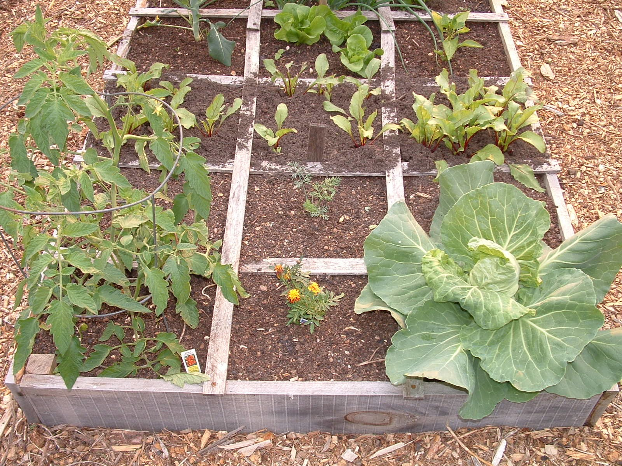

**Location**

* **Pick an area that gets 6-8 hours of sunshine daily.**

(Most plants need this much.)

* **Be sure it is not near trees and shrubs.**

(Where roots and shade do not interfere.)

* **Have it as close as possible to the house.**

(For convenience and protection.)

* **Existing soil is not really important.** (Since you probably won’t be using it.)
* **Area must not puddle after a heavy rain.** (In other words, good drainage.)

**Special Techniques**

An important advantage of the SFG method is the use of special techniques like incorporating natural pest deterrents, companion planting, crop rotation, and succession planting. These advantages can be accomplished virtually automatically, without the need for you to become an expert on each subject or to draw up any elaborate plans or diagrams.

Let’s first consider **companion planting** and interplanting with **pest deterrent plants**. All of your vegetable and flower squares are so close together (compared to a conventional garden) that you can have companions in almost every combination without much advanced planning. As long as you include pest-deterrent crops like onions, garlic, marigolds, and nasturtiums in your garden, you won’t have to worry about where to put them. Because the square foot garden is so small, the deterrent effects of the plants will be felt throughout. If, for example, onion will be used to deter various pests, you can grow a few squares of them in different parts of your garden. If you want to grow nasturtiums to deter aphids and several kinds of beetles, any square of nasturtiums that you plant will automatically be located within 3 feet of any other part of your garden.

**Crop rotation** will also occur automatically in the square foot garden. It is a well-known fact that you should never grow the same crop in the same botanical family in the same soil year after year. This is especially true of cole crops (cabbage, broccoli, etc.) and the nightshade family (tomatoes, potatoes, etc.). For best results, you should always rotate all your plants. Disease-causing organisms gradually accumulate in the soil over a period of time. Different crops are susceptible to different diseases, and growing the same crop in the same soil year after year may permit buildup of a high enough concentration of a specific organism to cause disease in that crop. Failure to rotate the crop also makes it more likely that the soil will be depleted of the nutrients which that crop uses, and the plants will be less healthy and more susceptible to pest attacks.

**Succession planting** works much the same way as companion planting. You quickly and easily replant as soon as one square is harvested. You may have a few squares too many or not enough of one crop, but you can easily adjust the next planting. You will find that your soil is never empty. You can always have new plants started in containers waiting to be transplanted into a space in the garden as soon as one becomes available.

**Interplanting** is just as easy because you will be more aware of how much room a plant needs if you always plant it in its final location or spacing. You know that bell peppers, for instance, need 1 foot spacing, so just plant one plant in the center of each square. After the plant is in place, you will see that the space around the outside edges of the square won’t be needed until the plant grows bigger. This is an excellent place to put a fast growing crop like radish, scallion, or even leaf lettuce to harvest when it is young. Plant a few seeds of these vegetables in the corners of the square when you plant the center plant, and you have interplanting.

### A garden for canning, freezing, or market: Gardeners who want to grow extra food for preserving or selling at market can plant foot/yard square blocks entirely in one crop for a maximum harvest. Plant all at once or successively, depending on how much you want and when.

### Understanding Soil

To garden in soil that is rich in organic matter but contains no added fertilizers is not only possible, but very practical. After all, Mother Nature does it all the time. The only disadvantage to organic matter is that it continually breaks down and decomposes, so you must add new material to your soil. With a SFG, you will be adding compost 3 to 6 times a year. The best source of organic matter for gardens is composted plant material. If you have a compost pile, you will have a ready source of humus to add to your garden. There three major nutrients and a host of minor ones used by most plants. Nitrogen (N) makes the luxurious green growth necessary for leaf crops. Phosphorus (P) promotes the development of strong stems and seeds as well as resistance to disease. Potassium (K) is needed for healthy stems and roots and for good fruit production. Plants use a long list of minor, or trace, elements. Like people, they need a balanced diet. The more variety you can put into your compost, the better will be your results. Good compost will provide a “balanced diet” for your garden plants.

### Plant Protection Cages

Basically, they are three-sided wire mesh “cages” made from common fencing wire to be placed over a particular garden square to support various protective coverings. There are four different protective cages, each with its own use. You can make a cage with a clear plastic cover for protection from frost, heavy rain or hail; one covered with a fine screen to keep out birds, small animals and harmful insects; a third type covered with shade material to protect young plants and summer-grown lettuce; and fourth, an uncovered frame with large openings which can be used to support plants without staking.

### Vertical Growing

The reasons for vertical gardening are many and varied. They include the use of much less garden space, increased yields, improved harvests, easier soil preparation, simplified watering methods, better plant health, and less damage to the stem when harvesting. In addition, a vertical garden is extremely attractive and enhances the appearance of any yard or home.

Just about any vegetable or flower that produces a vine or rambling stem can be grown vertically; cucumbers, pole beans, peas, melons, summer squash, and many flowers. Most of these plants will climb by themselves, grasping the support with their twisting tendrils. Others need to be attached by strings.

### How Much and How Often to Water

In addition to soil structure, watering techniques must, of course, be based on the requirements of the plants themselves. Some crops grow best with a constant, even supply of moisture. These include all root, leaf, and head crops. Such plants develop fairly shallow roots which depend heavily on constant soil moisture close to the surface.

In contrast, fruit or seed crops (such as tomatoes, cucumbers, eggplant, peppers, corn, beans, squash and melons like to send roots deeper into the ground so grow best with deep but less frequent watering. When these plants receive too much water, too often, they refuse to produce a good fruit crop, but instead grow lots of leaves and bushy tops. Remember, when there is a shortage of moisture, plants tend to flower and go to seed. As long as they have strong roots, plants won’t lack for some moisture, and won’t wilt and die.

Another consideration for the amount and frequency of watering is the age of the plant. Newly planted seeds require constant moisture right at the soil surface to germinate, so it is necessary to sprinkle them daily, sometimes more often if it is very hot, sunny and windy. When the seeds sprout, they must have moisture at the root level as well.

Young transplants also need a constant supply of moisture because they are undergoing a transplanting shock when moved, but you must be careful not to give them too much. The combination of just the right amount of moisture and the ideal growing conditions leads to a well-established transplant. Shading is important, too, for a young transplant, particularly on hot sunny days.

### Watering Tips to Remember

* Don’t water from overhead, instead water right around the stem
* Keep a bucket or two full of water in a sunny spot to have warm water always ready for the plants (use a white bucket so water doesn’t get too hot)
* Spray or mist newly planted seeds daily, or twice a day if necessary, to keep the soil moist
* Plant each plant in a shallow depression to conserve water
* Water immediately after transplanting
* With the cup and bucket method, time of day to water is not so important. If you have a choice, water in the morning.

### Pest Control

Keeping pests under control requires constant vigilance from every gardener. Synthetic pesticides are expensive and there is concern about their long-range harmful effects. Better than using poisons, and much safer, easier, and cheaper is to try some simple pest control methods. These work well because your garden is so small. As you work, you are close to each plant. Notice holes chewed in the leaves and look for the chewer. Your eyes and hands are your tools. You can put netting over an area. Onions, dill, marigold, and nasturtium all repel insects.

### Weeds

The secret to a weed free garden is in keeping up with the weeding, and having a small area to take care of. Another factor that discourages weeds in SFG is that the close plant spacing gradually creates a living mulch. As the plants grow, their leaves throw more shade on the adjoining ground until the planted vegetables cover the entire area. Then, very few weed seeds will sprout, and those that do will be weak and spindly and very easy to pull out of the loose, crumbly soil. Your fingers are the only tool you need! A good compost is weed free.

### What kinds of crops can you grow?

##### How many plants per square?

|  |  |  |
| --- | --- | --- |
| Roots/Tubers | **Leaf Crops** | **Legumes/Other**  1 ft.  1 ft.  1 ft.  1 ft. |
| Potatoes 1  Sweet potatoes 1  Manioc 1  Beets 9  Carrots 16  Turnips 9  Radish 16  Onion (small) 16  Onion (larger) 9 | Cabbage family Broccoli 1  Kale 1  Collards 1  Cabbages 1  Bok Choy 4 Lettuce & Other Fancy 4  European greens 4  Chards 4  Spinach 9  New Zealand Spinach 1 | Beans Green (string) 5  Soy 4  Fava 4  Peas 9  **Other**  Melons 1  Squash 1  Tomatoes 1  Artichoke 1  Corn 2  Eggplant 1  Cucumber 1  Okra 2  Peppers 1  Pumpkins 1 |
| **Herbs** | **Other** | **Special** |
| Parsley 4  Onion (green) 16  Cilantro 4  Basil 4  Oregano 4  Mint 4 | Horseradish 1  Ginger 1  Garlic 9 | Medicinal  Cultural  (Follow local customs) |

